Materials and Tools Needed

Materials

* Structure Components
  + 3 Rails ( w/ limit switch cut out )
  + 1 Rail ( w/o limit switch cut out )
  + Top Panel
  + Bottom Panel
  + Threaded Center Support
  + Center Support
* Fasteners
  + 6 mm M2 screws
  + 8 mm M2 screws
  + 10 mm M2 screws
  + 8 mm M3 screws
  + M3 washers
  + M2 Nuts
* Secondary Structural Components
  + 4 M3 steel internal rods
  + Spacers
  + M3 Nuts
* Solar Panel Assembly
  + Solar Panels
  + Antennas (Measuring Tape)
  + Roll Nichrome Wire (38 Gauge)
  + Roll of Fishing Line

Tools

* Metric Allen Wrench set
* Precision Tweezers Set
* Grounding Wrist bands
* Kapton Tape
* Scissors

Building Procedure

Preparation

1. Gather all necessary materials and tools needed
2. If the CubeSat Skeleton has been previously taken apart, proceed to the Building Procedures. Otherwise follow the next few steps in taking apart the CubeSat Skeleton.
3. Remove screws on the top sides of the skeleton and remove the top structure.
4. On the top structure, remove and store the pegs.
5. Remove screws on the bottom sides of the skeleton and remove the bottom structure.
6. On the bottom structure, remove and store pegs.
7. Verify all necessary materials and tools have been collected.

BUILD

1. Line up structure parts in correct order (top, internal and bottom panels, RBF bracket, rails, and rods)

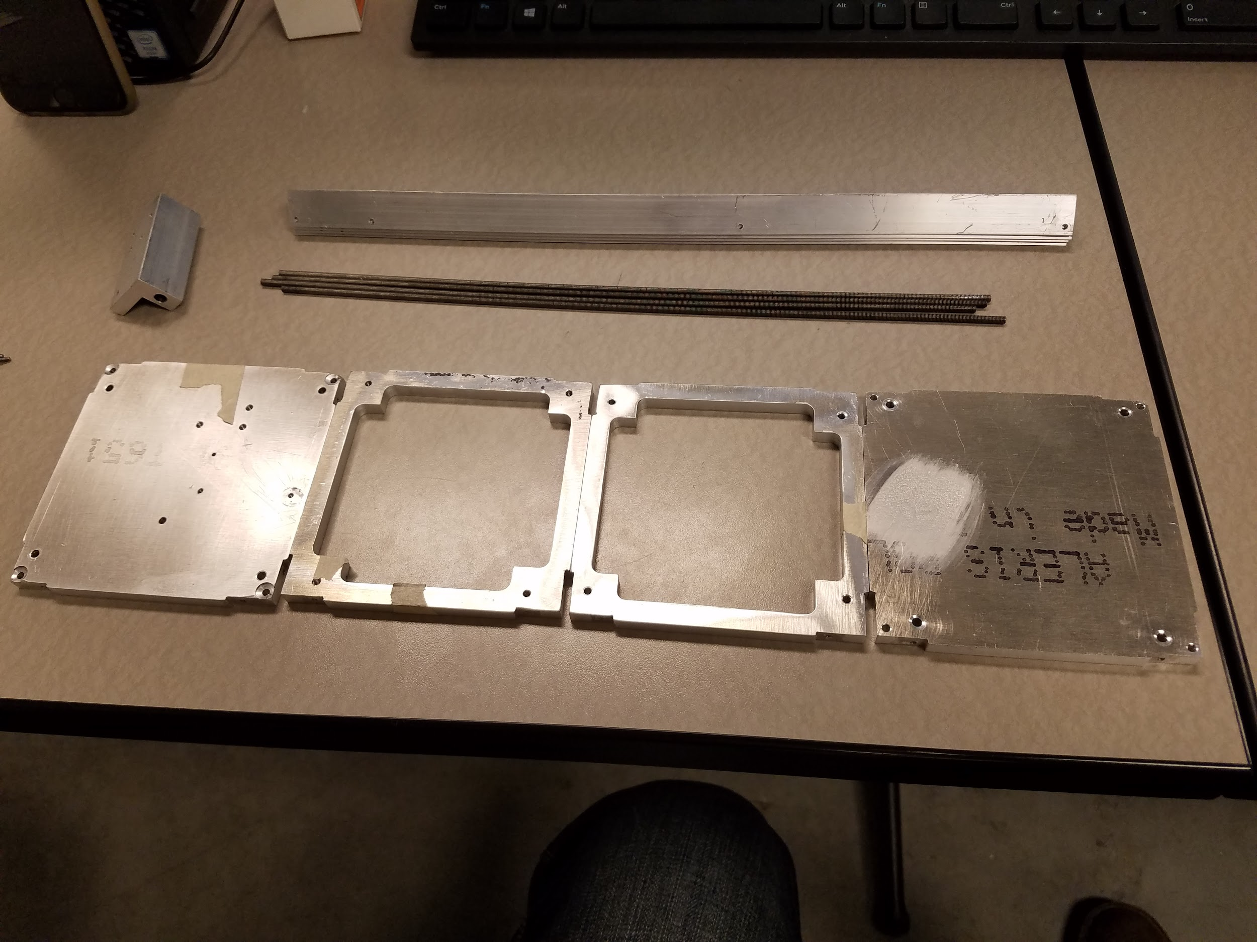

Figure 1: All Primary and Secondary Components

1. Identify the top of the top panel
   1. Make sure the holes that attach the RBF Bracket to the top panel line up on the correct side. This refers to the circled holes in figure 2. The bracket will only attach in one orientation.

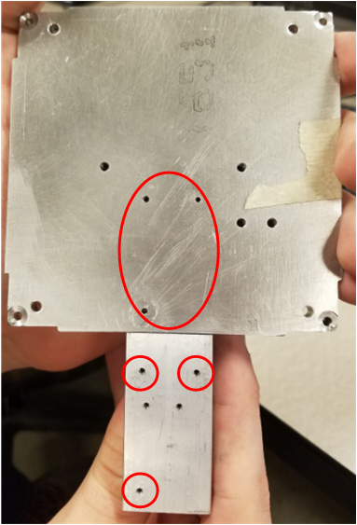

Figure 2: Alignment of RBF bracket and Top Panel

* 1. The side that the RBF bracket does **not** attach to is the top (outer surface) of the top panel. Mark this side for future reference

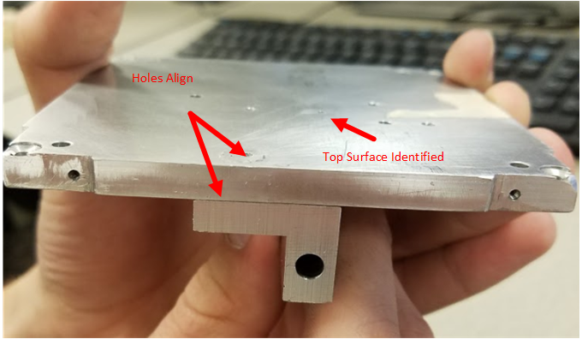

Figure 3: Identifying the Top Surface

1. Fasten the RBF bracket to the top panel with 10 mm M2 screws using the holes identified in figure 2. Make sure it is on the correct side of the satellite.
2. Attach the standoffs to the top panel using the holes circled in blue in figure 4 on the opposite side of the top panel from the RBF bracket. Mount on the side marked top surface identified in figure 3.
3. Line up the holes for the internal rods for each lateral panel (markings might be added)
   1. T for top
   2. The red circled holes in figure 4 indicate the holes that must line up on each panel. The alignment should be nearly exact. They are ways they can be aligned that are close, but not accurate, be careful. Mark all sides on the opposite side of the RBF bracket with tape (This indicates the side the electronic board buses attach to)

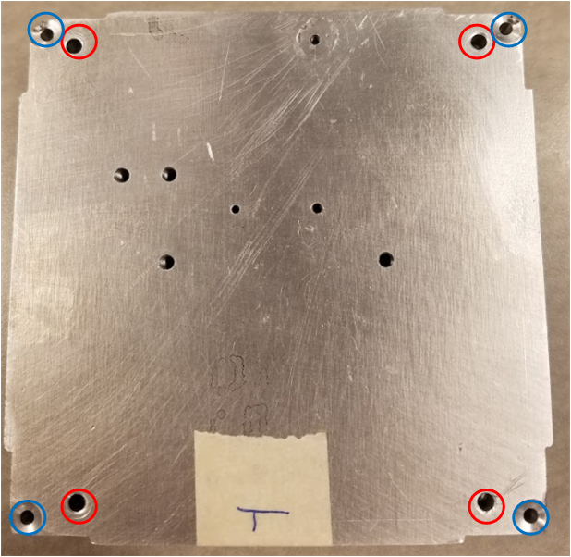

Figure 4: Top Panel Holes (Blue: Standoff Mounting | Red: Rod Alignment)

1. Pick up Rail w/o limit switch cut out
2. Fasten this Rail to top panel
   1. Possible shim placement for hole alignment
   2. This bracket is placed as shown in figure 5
   3. Use 6 mm M2 screws (fit may be loose at this point because solar panels are not attached. For loose fitting screws, add an M3 nut as a spacer as shown in figure 6. This applies for any loose screw in remaining steps)

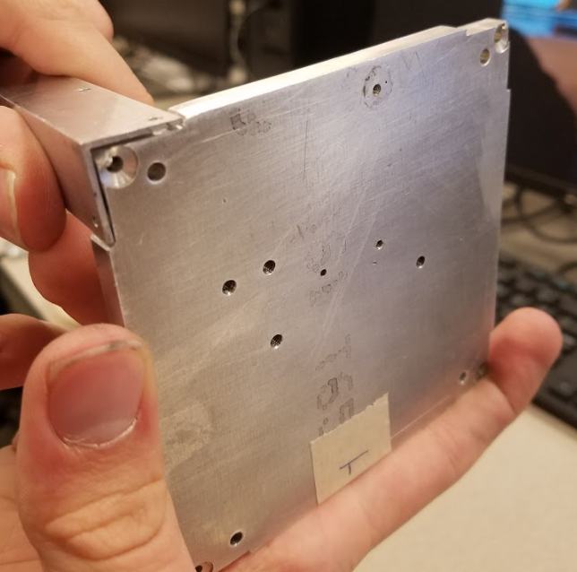

Figure 5: Non-RBF switch bracket placement

1. Fasten the remaining 3 rails with the limit switch cut out to the top panel
   1. Make sure the cut out is near the top panel
   2. Use 6 mm M2 screws (again fit may be loose. Also one of the sides will have shallower holes which is to be expected. Screws won’t fit as well on this side)

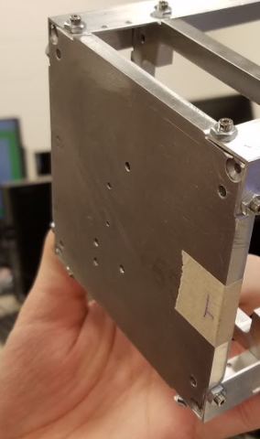

Figure 6: All 4 Rails Attached to Bottom Panel

1. Screw the internal rods into the bottom of the Threaded Center Support
   1. The holes for the internal rods are threaded
   2. Make sure when completing this step that the rods extend towards the bottom of the satellite in the opposite direction of the top face of the top panel identified in step 2.
2. Fasten the Threaded Center Support to the Rails
   1. It goes on with the internal rods already in it, don’t let them bend too much when handling
   2. It goes just below the cutouts on the rails.
   3. Use 6 mm M2 screws
   4. Make sure the holes for the internal rods, and the side that the electronics bus is on are aligned between the internal panel and the top panel to ensure proper placement. The assembly should look similar to figure 7:

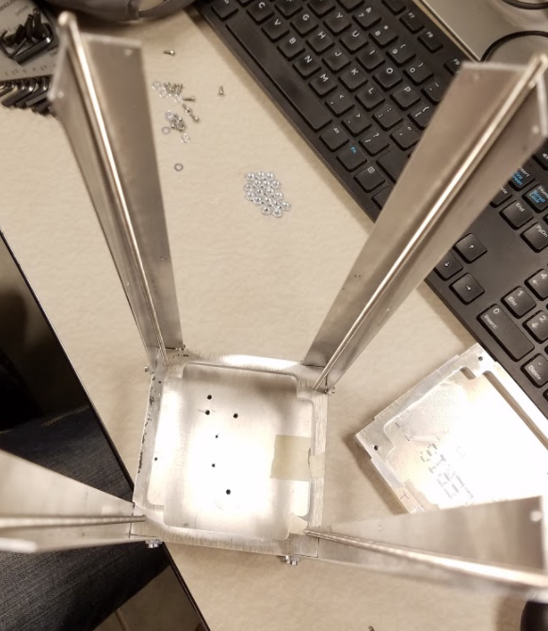

Figure 7: Top and Internal Panel Integrated

1. Put in the main stack of boards
   1. Put the spacers in between each board and structure
   2. Do necessary wiring
   3. Make sure wires that go to the solar panel assembly, communication antennas, and payload are in convenient places for later use
   4. Properly handle the electronics and use the electronics work area grounding wrist bands
2. Fasten the Unthreaded Center Support to the Rails
   1. Make sure the top is facing the top panel
   2. Use 6 mm M2 screws
   3. Make sure the holes for the internal rods, and the side that the electronics bus is on are aligned between the top panel and both internal panels to ensure panels are oriented correctly
   4. Slide it on to the internal rods, then fasten with screws
   5. Figure 8 shows this panel attached without the rods and boards as they were not acquired at the time of this writing.

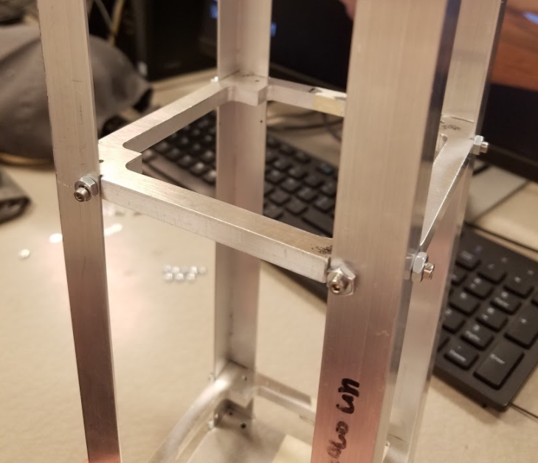

Figure 8: Unthreaded Panel Placement

1. Attach the payload, and wire it to the main stack
2. Attach 4 standoffs to the bottom panel of the satellite
   1. Make sure they are on the bottom of the bottom panel
   2. Attach with M3 bolts
3. Attach bottom panel solar panel through provided holes with M2 bolts
4. Fasten the Bottom Panel to the Rails
   1. Make sure the top is facing the top panel
   2. Use 6 mm M2 screws
   3. Make sure the holes for the internal rods, and the side that the electronics bus is on are aligned to ensure proper fit
   4. Slide it on to the internal rods, then fasten with screws
5. The structure should have all internal components added at this point and no solar panels should be on the vertical sides
6. Attach the top panel solar panel using holes provided and the extra space at the top
7. Attach the limit switch on the three rails with cutouts. They should be attached with bolts through the holes shown in figure 9. The head of the limit switch should be sticking out of the rail

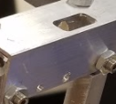

Figure 9: Limit Switch Attachment Point

1. Large solar panels will be attached one side at a time. Remove all bolts from one side of the satellite, line up the panel and reattach the screws through the holes. Repeat this for all 3 panels as well as the magnetometer panel.